**PRACTICAL – 10**

**AIM:**

* Introduction to I-phone & installation of x-code on MAC.

**THEORY:**

**What is Xcode?**

* Xcode is an application that developers use to build apps for Apple’s various platforms such as iPhone, iPad, Macs, AppleTV and Apple Watch.

**Step – 0 Check your mac OS Version:**

* We will be using the latest version of Apple’s Xcode 11 to program iOS 13 apps and run our apps in Xcode’s built in iOS simulator.
* Xcode is an Integrated Development Environment (IDE) developed by Apple and the vast majority of iOS developers rely on it for making iPhone or iPad applications. Xcode 11 can only be installed on a Mac running macOS 10.14.4 (Mojave) or above. But ideally, you should be running macOS 10.15.0 or above Catalina).
* If you are still running an earlier OS such as Mavericks, Yosemite, El Capitan, Sierra etc, you will need to update your OS. Have a look on Apple’s website for instructions on how to do so.
* Check that your OS is either Mojave 10.14.4 or above or Catalina 10.15 If your version is lower than this, head over to the Mac App Store and you can upgrade your operating system to the latest version of macOS Catalina for free.

**Step 1: Open the App Store:**

* Once you’re sure you are running the correct version of the Mac operating system, you can get started with downloading Xcode 11 through the Mac App Store. Open the App Store app on your Mac. By default, the App Store is in the Dock. You can also find it in your Launchpad.



**Step 2: Search for Xcode:**

* In the search field in the top-right corner, type Xcode and press the Return key.

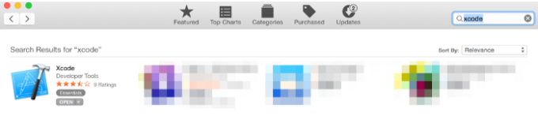

**Step 3: Install Xcode:**

* Xcode is a free application developed by Apple, so just click the “Get” or “Download” button and start the installation process.



* Xcode is several gigabytes in size so downloading it could take a while. By default, Xcode is downloaded into your /Applications directory.

**Step 4: Launch Xcode:**

* Launch Xcode. Do you see the Welcome to Xcode window and the version is 11.0 or above (e.g 11.1 or 11.1.2 etc.)? If yes, then great, we’re all done!

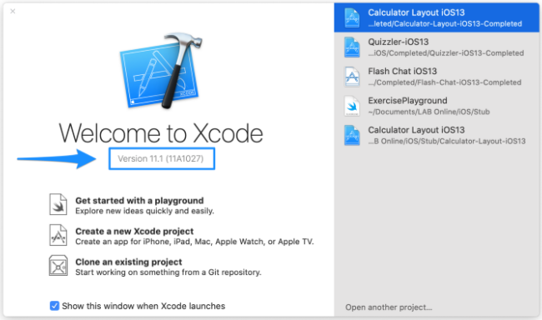

* By the end of this chapter, you’ll have a great understanding of how to navigate the development environment and how to create your first Xcode project.
* Before we dive in, keep this Apple Documentation for Xcode handy.
* Let’s now look at the diagram below. If your interface looks different, make sure you have Xcode 11 and not an earlier version.

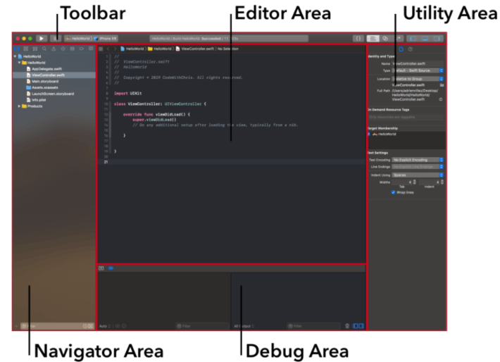

* The reason this is a great diagram is because it lets me refer to these different sections of the interface and you can refer back to this diagram to see what I’m talking about!
* As you can see from the diagram, there are 5 major areas: the Navigator, Editor, Utility Area, Toolbar and Debug Area. We’ll cover each area in detail later but for now, let’s talk about general navigation of Xcode.
* Keep in mind that you can adjust the size of each of those panes by hovering your cursor over the boundaries of each area and dragging.
* You can also show and hide the various areas as needed via the “View” buttons in the upper right hand corner:

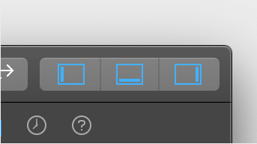

* This can be helpful, for example, when you’re writing code and you don’t need the debugger area or the utility area. Then you can use the View buttons to hide those 2 panes to give your editor more visible space.

